**DIGITAL MARKETING**

**ASSIGNMENT :1**

|  |  |
| --- | --- |
| Name | ASHA.S.C |
| Reg No | 960220106031 |
| NM ID | 107BEDF635F7475952248BDD170F8CD9 |
| Team ID | NM2023TMID10148 |

Create a blog or website using Blogspot and WordPress.  
Customize the theme design and post new article with 500  
words.

Blogspot: <https://attratefashion.blogspot.com/2023/08/nixon-fashion-model.html>

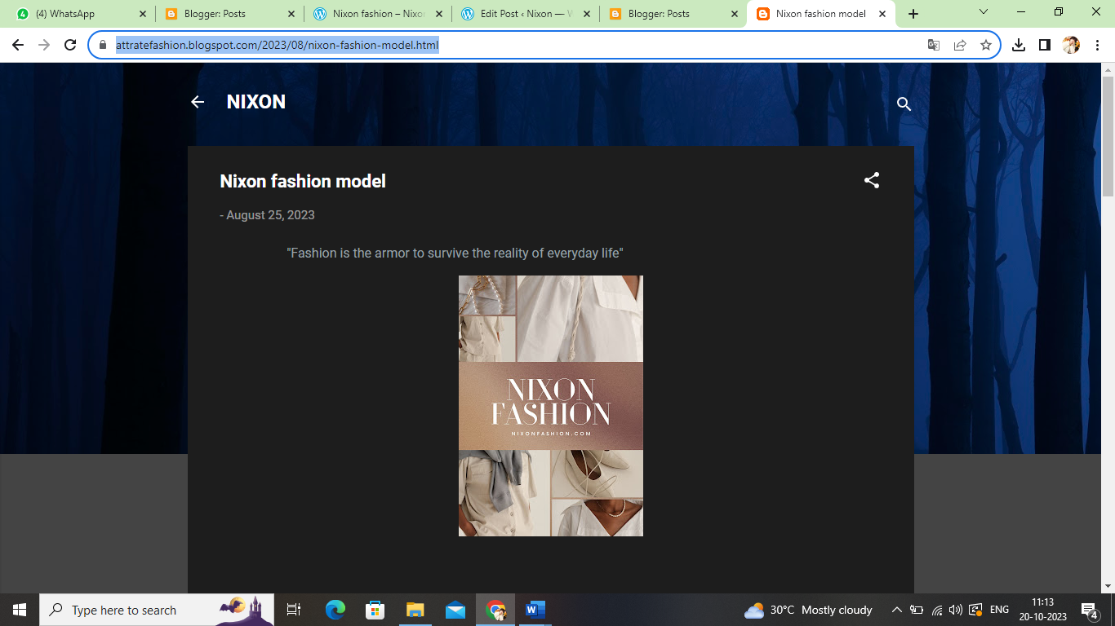

WordPress: <https://wordpress.com/post/nixonfasion.wordpress.com/8>

